***Percentile Assignment***

* The dataset is based on “Placement” of HSC_P Student dataset.
* Based on the dataset can able to analyze about the range of data exist in dataset.

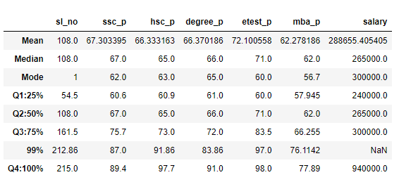

“The above table shows the student percentile of SSC, HSC, Degree, Entrance, MBA Pass score and salary of the student.”

* In SSC pass – 25% of student got 60.6 marks , 50% of student got 67.0 marks, 75% of student got 75.7 marks, 99% of student got 87.0 marks , 100% of student got 89.4 marks.
* In HSC pass – 25% of student got 60.9 marks, 50% of student got 65.0 marks, 75% of student got 73.0 marks, 99% of student got 91.86 marks, 100% of student got 97.7 marks.
* In Degree pass – 25% of student got 61.0 marks, 50% of student got 66.0 marks, 75% ofstudent got 72 marks, 99% of student got 83.86 marks, 100% of student got 91.0 marks.
* In Entrance pass – 25% of student got 60 marks 50% of student got 71 marks, 75% of student got 83.5 marks, 99% of student got 97.0 marks, 100% of student got 98.0 marks.
* In MBA pass – 25% of student got 57.945 marks, 50% of student got 62 marks, 75% of student got 66.255 marks, 99% of student got 76.1142 marks, 100% of student got 77.89 marks.
* In Salary – 25% of student got 240000 salary, 50% of student got 265000 salary, 75% of student got 300000 salary, 99% of student got NAN (due to nan value in dataset), 100% of student got 940000 salary.